**ABSTRACT**

Since the coronavirus has shown up, the inaccessibility of legitimate clinical resources is at its peak, like the shortage of specialists and healthcare workers, lack of proper equipment and medicines etc. The entire medical fraternity is in distress, which results in numerous individual’s demise. Due to unavailability, individuals started taking medication independently without appropriate consultation, making the health condition worse than usual. As of late, machine learning has been valuable in numerous applications, and there is an increase in innovative work for automation. This paper intends to present a drug recommender system that can drastically reduce specialists' heap. In this research, we build a medicine recommendation system that uses patient reviews to predict the sentiment using various vectorization processes like Bow, TF-IDF, Word2Vec, and Manual Feature Analysis, which can help recommend the top drug for a given disease by different classification algorithms. The predicted sentiments were evaluated by precision, recall, f1score, accuracy, and AUC score. The results show that classifier LinearSVC using TF-IDF vectorization outperforms all other models with 93% accuracy. Index Terms—Drug, Recommender System, Machine Learning, NLP, Smote, Bow, TF-IDF, Word2Vec, Sentiment analysis

**SYSTEM CONFIGURATION:**

**Hardware requirements:**

Processor :           Intel i5 CORE

RAM :           Min 8 GB

Hard Disk :           Min 250 GB

**Software requirements:**

Operating System :         Windows family

Technology :     Python 3.6

Code Dev. IDE : Jupyter Notebook

**INTRODUCTION**

With the number of coronavirus cases growing exponentially, the nations are facing a shortage of doctors, particularly in rural areas where the quantity of specialists is less compared to urban areas. A doctor takes roughly 6 to 12 years to procure the necessary qualifications. Thus, the number of doctors can’t be expanded quickly in a short time frame. A Telemedicine framework ought to be energized as far as possible in this difficult time [1]. Clinical blunders are very regular nowadays. Over 200 thousand individuals in China and 100 thousand in the USA are affected every year because of prescription mistakes. Over 40% medicine, specialists make mistakes while prescribing since specialists compose the solution as referenced by their knowledge, which is very restricted [2][3]. Choosing the toplevel medication is significant for patients who need specialists that know wide-based information about microscopic organisms, antibacterial medications, and patients [6]. Every day a new study comes up with accompanying more drugs, tests, accessible for clinical staff every day. Accordingly, it turns out to be progressively challenging for doctors to choose which treatment or medications to give to a patient based on indications, past clinical history. With the exponential development of the web and the web-based business industry, item reviews have become an imperative and integral factor for acquiring items worldwide. Individuals worldwide become adjusted to analyze reviews and websites first before settling on a choice to buy a thing. While most of past exploration zeroed in on rating expectation and proposals on the E-Commerce field, the territory of medical care or clinical therapies has been infrequently taken care of. There has been an expansion in the number of individuals worried about their well-being and finding a diagnosis online. As demonstrated in a Pew American Research Center survey directed in 2013 [5], roughly 60% of grown-ups searched online for health-related subjects, and around 35% of users looked for diagnosing health conditions on the web. A medication recommender framework is truly vital with the goal that it can assist specialists and help patients to build their knowledge of drugs on specific health conditions. A recommender framework is a customary system that proposes an item to the user, dependent on their advantage and necessity. These frameworks employ the customers’ surveys to break down their sentiment and suggest a recommendation for their exact need. In the drug recommender system, medicine is offered on a specific condition dependent on patient reviews using sentiment analysis and feature engineering. Sentiment analysis is a progression of strategies, methods, and tools for distinguishing and extracting emotional data, such as opinion and attitudes, from language [7]. On the other hand, Featuring engineering is the process of making more features from the existing ones; it improves the performance of models. This examination work separated into five segments: Introduction area which provides a short insight concerning the need of this research, Related works segment gives a concise insight regarding the previous examinations on this area of study, Methodology part includes the methods adopted in this research, The Result segment evaluates applied model results using various metrics, the Discussion section contains limitations of the framework, and lastly, the conclusion section

**LITERATURE SURVEY**

With a sharp increment in AI advancement, there has been an exertion in applying machine learning and deep learning strategies to recommender frameworks. These days, recommender frameworks are very regular in the travel industry, e-commerce, restaurants, and so forth. Unfortunately, there are a limited number of studies available in the field of drug proposal framework utilizing sentiment analysis on the grounds that the medication reviews are substantially more intricate to analyze as it incorporate clinical wordings like infection names, reactions, a synthetic names that used in the production of the drug [8]. The study [9] presents GalenOWL, a semantic-empowered online framework, to help specialists discover details on the medications. The paper depicts a framework that suggests drugs for a patient based on the patient’s infection, sensitivityties, and drug interactions. For empowering GalenOWL, clinical data and terminology are first converted to ontological terms utilizing worldwide standards, such as ICD-10 and UNII, and then correctly combined with the clinical information. Leilei Sun [10] examined large-scale treatment records to locate the best treatment prescription for patients. The idea was to use an efficient semantic clustering algorithm estimating the similarities between treatment records. Likewise, the author created a framework to assess the adequacy of the suggested treatment. This structure can prescribe the best treatment regimens to new patients as per their demographic locations and medical complications. An Electronic Medical Record (EMR) of patients gathered from numerous clinics for testing. The result shows that this framework improves the cure rate. In this research [11], multilingual sentiment analysis was performed using Naive Bayes and Recurrent Neural Network (RNN). Google translator API was used to convert multilingual tweets into the English language. The results exhibit that RNN with 95.34% outperformed Naive Bayes, 77.21%. The study [12] is based on the fact that the recommended drug should depend upon the patient’s capacity. For example, if the patient’s immunity is low, at that point, reliable medicines ought to be recommended. Proposed a risk level classification method to identify the patient’s immunity. For example, in excess of 60 risk factors, hypertension, liquor addiction, and so forth have been adopted, which decide the patient’s capacity to shield himself from infection. A web-based prototype system was also created, which uses a decision support system that helps doctors select first-line drugs. Xiaohong Jiang et al. [13] examined three distinct algorithms, decision tree algorithm, support vector machine (SVM), and backpropagation neural network on treatment data. SVM was picked for the medication proposal module as it performed truly well in each of the three unique boundaries - model exactness, model proficiency, model versatility. Additionally, proposed the mistake check system to ensure analysis, precision and administration quality. Mohammad Mehedi Hassan et al. [14] developed a cloudassisted drug proposal (CADRE). As per patients’ side effects, CADRE can suggest drugs with top-N related prescriptions. This proposed framework was initially founded on collaborative filtering techniques in which the medications are initially bunched into clusters as indicated by the functional description data. However, after considering its weaknesses like computationally costly, cold start, and information sparsity, the model is shifted to a cloud-helped approach using tensor decomposition for advancing the quality of experience of medication suggestion. Considering the significance of hashtags in sentiment analysis, Jiugang Li et al. [15] constructed a hashtag recommender framework that utilizes the skip-gram model and applied convolutional neural networks (CNN) to learn semantic sentence vectors. These vectors use the features to classify hashtags using LSTM RNN. Results depict that this model beats the conventional models like SVM, Standard RNN. This exploration depends on the fact that it was undergoing regular AI methods like SVM and collaborative filtering techniques; the semantic features get lost, which has a vital influence in getting a decent expectation.

**History of Python**

Python was developed by Guido van Rossum in the late eighties and early nineties at the National Research Institute for Mathematics and Computer Science in the Netherlands.Python is derived from many other languages, including ABC, Modula-3, C, C++, Algol-68, SmallTalk, and Unix shell and other scripting languages.

Python is copyrighted. Like Perl, Python source code is now available under the GNU General Public License (GPL).

Python is now maintained by a core development team at the institute, although Guido van Rossum still holds a vital role in directing its progress.

**Technical Feasibility**

Technical resources need for project Development

* Windows family Operating System
* Python 3.6 Technology
* Jupyter Notebook

**LSTM**

LSTM networks are an extension of recurrent neural networks ([RNNs](https://www.geeksforgeeks.org/introduction-to-recurrent-neural-network/)) mainly introduced to handle situations where RNNs fail.

* It fails to store information for a longer period of time. At times, a reference to certain information stored quite a long time ago is required to predict the current output. But RNNs are absolutely incapable of handling such “long-term dependencies”.
* There is no finer control over which part of the context needs to be carried forward and how much of the past needs to be ‘forgotten’.
* Other issues with RNNs are exploding and vanishing gradients (explained later) which occur during the training process of a network through backtracking.

Thus, Long Short-Term Memory ([LSTM](https://www.geeksforgeeks.org/long-short-term-memory-networks-explanation/)) was brought into the picture. It has been so designed that the vanishing gradient problem is almost completely removed, while the training model is left unaltered. Long-time lags in certain problems are bridged using LSTMs which also handle noise, distributed representations, and continuous values. With LSTMs, there is no need to keep a finite number of states from beforehand as required in the hidden [Markov model](https://www.geeksforgeeks.org/hidden-markov-model-in-machine-learning/) (HMM). LSTMs provide us with a large range of parameters such as learning rates, and input and output biases.

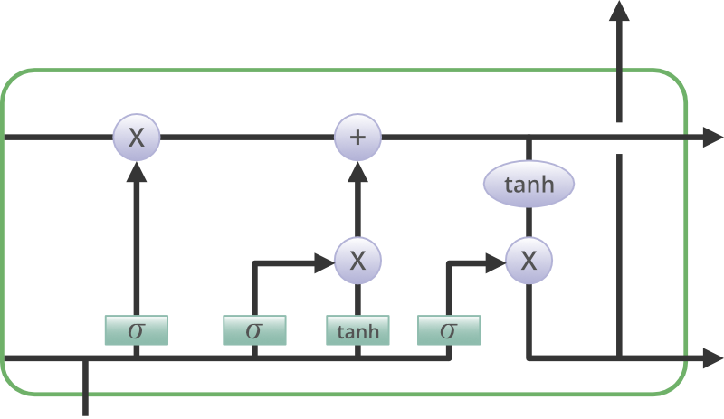

**IMPLEMENTATION**

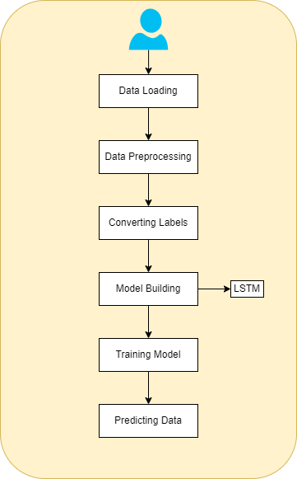

**RESULT SCREEN SHORTS**

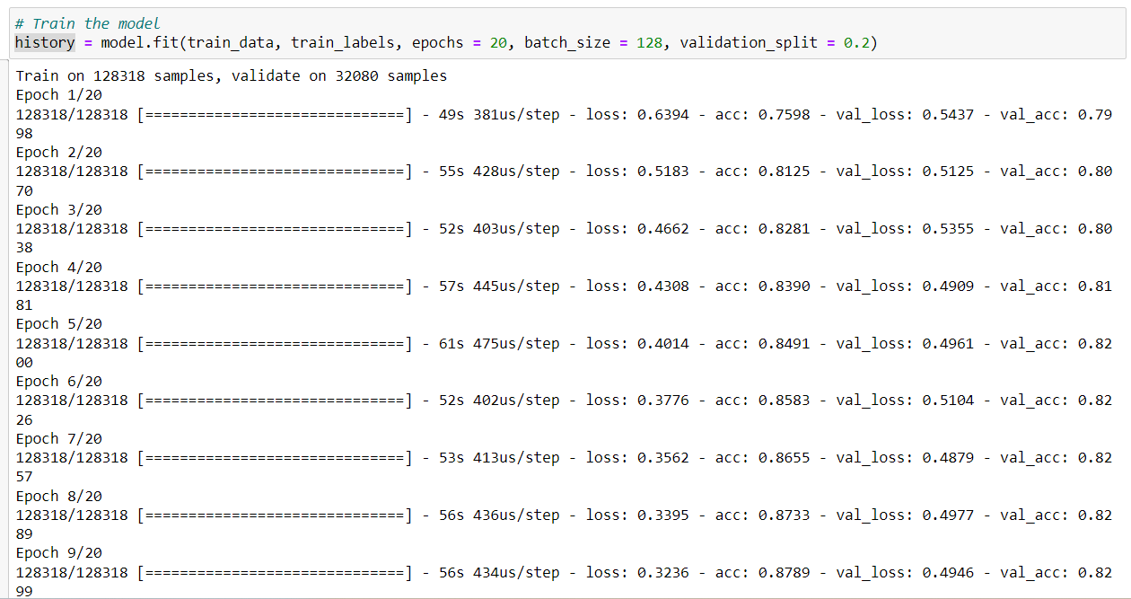

Figure-1. Mode Training

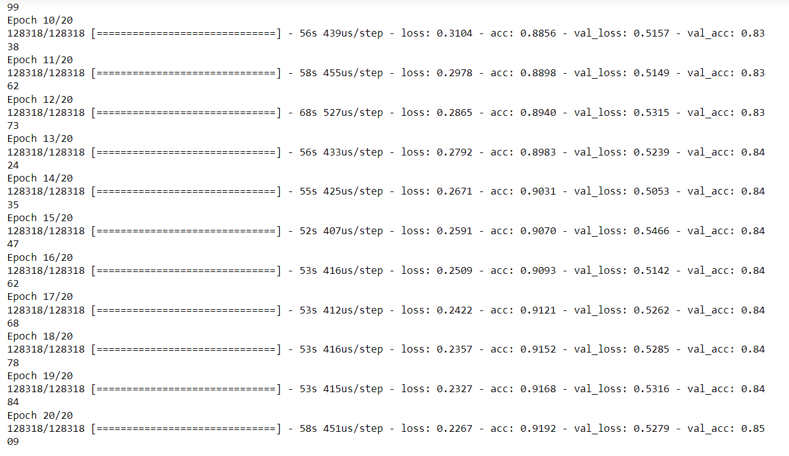

Figure-2. Mode Training

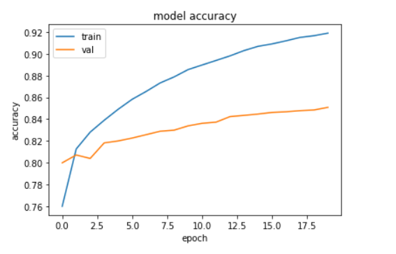

Figure-3. Accuracy Graph Of Model

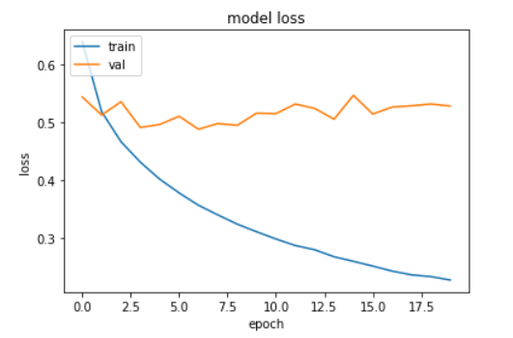

Figure-4. Loss Graph Of Model

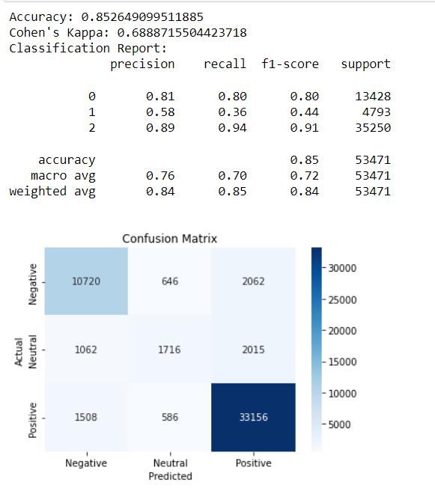

Figure-5.Confusion Matrix And Evaluations

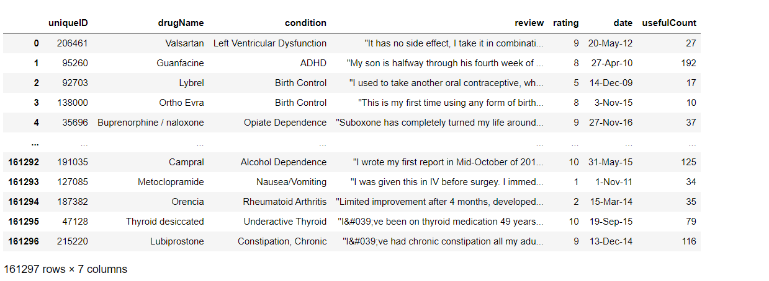

Figure-6. Data Reading

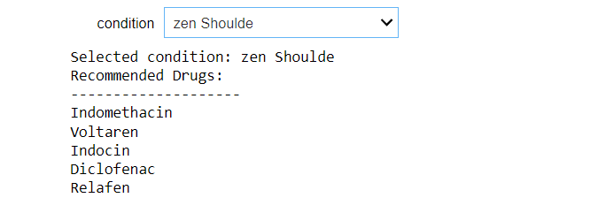

Figure-7. Prediction Result

**CONCLUSION**

Reviews are becoming an integral part of our daily lives; whether go for shopping, purchase something online or go to some restaurant, we first check the reviews to make the right decisions. Motivated by this, in this research sentiment analysis of drug reviews was studied to build a recommender system using different types of machine learning classifiers, such as Logistic Regression, Perceptron, Multinomial Naive Bayes, Ridge classifier, Stochastic gradient descent, LinearSVC, applied on Bow, TF-IDF, and classifiers such as Decision Tree, Random Forest, Lgbm, and Catboost were applied on Word2Vec and Manual features method. We evaluated them using five different metrics, precision, recall, f1score, accuracy, and AUC score, which reveal that the Linear SVC on TF-IDF outperforms all other models with 93% accuracy. On the other hand, the Decision tree classifier on Word2Vec showed the worst performance by achieving only 78% accuracy. We added best-predicted emotion values from each method, Perceptron on Bow (91%), LinearSVC on TF-IDF (93%), LGBM on Word2Vec (91%), Random Forest on manual features (88%), and multiply them by the normalized usefulCount to get the overall score of the drug by condition to build a recommender system. Future work involves comparison of different oversampling techniques, using different values of n-grams, and optimization of algorithms to improve the performance of the recommender system.

**REFERENCES**

[1] Telemedicine, <https://www.mohfw.gov.in/pdf/Telemedicine.pdf>

[2] Wittich CM, Burkle CM, Lanier WL. Medication errors: an overview for clinicians. Mayo Clin Proc. 2014 Aug;89(8):1116-25.

[3] CHEN, M. R., & WANG, H. F. (2013). The reason and prevention of hospital medication errors. Practical Journal of Clinical Medicine, 4.

[4] Drug Review Dataset, https://archive.ics.uci.edu/ml/datasets/Drug% 2BReview%2BDataset%2B%2528Drugs.com%2529#

[5] Fox, Susannah, and Maeve Duggan. ”Health online 2013. 2013.” URL: <http://pewinternet.org/Reports/2013/Health-online.aspx>

[6] Bartlett JG, Dowell SF, Mandell LA, File TM Jr, Musher DM, Fine MJ. Practice guidelines for the management of community-acquired pneumonia in adults. Infectious Diseases Society of America. Clin Infect Dis. 2000 Aug;31(2):347-82. doi: 10.1086/313954. Epub 2000 Sep 7. PMID: 10987697; PMCID: PMC7109923.

[7] Fox, Susannah & Duggan, Maeve. (2012). Health Online 2013. Pew Research Internet Project Report.

[8] T. N. Tekade and M. Emmanuel, ”Probabilistic aspect mining approach for interpretation and evaluation of drug reviews,” 2016 International Conference on Signal Processing, Communication, Power and Embedded System (SCOPES), Paralakhemundi, 2016, pp. 1471-1476, doi: 10.1109/SCOPES.2016.7955684.

[9] Doulaverakis, C., Nikolaidis, G., Kleontas, A. et al. GalenOWL: Ontology-based drug recommendations discovery. J Biomed Semant 3, 14 (2012). <https://doi.org/10.1186/2041-1480-3-14>

[10] Leilei Sun, Chuanren Liu, Chonghui Guo, Hui Xiong, and Yanming Xie. 2016. Data-driven Automatic Treatment Regimen Development and Recommendation. In Proceedings of the 22nd ACM SIGKDD International Conference on Knowledge Discovery and Data Mining (KDD ’16). Association for Computing Machinery, New York, NY, USA, 1865–1874. DOI:https://doi.org/10.1145/2939672.2939866

[11] V. Goel, A. K. Gupta and N. Kumar, ”Sentiment Analysis of Multilingual Twitter Data using Natural Language Processing,” 2018 8th International Conference on Communication Systems and Network Technologies (CSNT), Bhopal, India, 2018, pp. 208-212, doi: 10.1109/CSNT.2018.8820254.

[12] Shimada K, Takada H, Mitsuyama S, et al. Drug-recommendation system for patients with infectious diseases. AMIA Annu Symp Proc. 2005;2005:1112.

[13] Y. Bao and X. Jiang, ”An intelligent medicine recommender system framework,” 2016 IEEE 11th Conference on Industrial Electronics and Applications (ICIEA), Hefei, 2016, pp. 1383-1388, doi: 10.1109/ICIEA.2016.7603801.

[14] Zhang, Yin & Zhang, Dafang & Hassan, Mohammad & Alamri, Atif & Peng, Limei. (2014). CADRE: Cloud-Assisted Drug REcommendation Service for Online Pharmacies. Mobile Networks and Applications. 20. 348-355. 10.1007/s11036-014-0537-4.

[15] J. Li, H. Xu, X. He, J. Deng and X. Sun, ”Tweet modeling with LSTM recurrent neural networks for hashtag recommendation,” 2016 International Joint Conference on Neural Networks (IJCNN), Vancouver, BC, 2016, pp. 1570-1577, doi: 10.1109/IJCNN.2016.7727385. [16] Zhang, Yin & Jin, Rong & Zhou, Zhi-Hua. (2010). Understanding bag-of-words model: A statistical framework. International Journal of Machine Learning and Cybernetics. 1. 43-52. 10.1007/s13042-010-0001- 0.

[17] J. Ramos et al., “Using tf-idf to determine word relevance in document queries,” in Proceedings of the first instructional conference on machinelearning, vol. 242, pp. 133–142, Piscataway, NJ, 2003.

[18] Yoav Goldberg and Omer Levy. word2vec Explained: deriving Mikolov et al.’s negative-sampling word-embedding method, 2014; arXiv:1402.3722.

[19] Danushka Bollegala, Takanori Maehara and Kenichi Kawarabayashi. Unsupervised Cross-Domain Word Representation Learning, 2015; arXiv:1505.07184.

[20] Textblob, <https://textblob.readthedocs.io/en/dev/>.

[21] van der Maaten, Laurens & Hinton, Geoffrey. (2008). Viualizing data using t-SNE. Journal of Machine Learning Research. 9. 2579-2605.

[22] N. V. Chawla, K. W. Bowyer, L. O. Hall and W. P. Kegelmeyer. SMOTE: Synthetic Minority Over-sampling Technique, 2011, Journal Of Artificial Intelligence Research, Volume 16, pages 321-357, 2002; arXiv:1106.1813. DOI: 10.1613/jair.953.

[23] Powers, David & Ailab,. (2011). Evaluation: From precision, recall and F-measure to ROC, informedness, markedness & correlation. J. Mach. Learn. Technol. 2. 2229-3981. 10.9735/2229-3981

[24] Haibo He, Yang Bai, E. A. Garcia and Shutao Li, ”ADASYN: Adaptive synthetic sampling approach for imbalanced learning,” 2008 IEEE International Joint Conference on Neural Networks (IEEE World Congress on Computational Intelligence), Hong Kong, 2008, pp. 1322-1328, doi: 10.1109/IJCNN.2008.4633969.

[25] Z. Wang, C. Wu, K. Zheng, X. Niu and X. Wang, ”SMOTETomekBased Resampling for Personality Recognition,” in IEEE Access, vol. 7, pp. 129678-129689, 2019, doi: 10.1109/ACCESS.2019.2940061.